Develop neural network-based time series forecasting model
EX:No.9
DATE:19/04/25

AIM:
Write a program to Develop neural network-based time series forecasting model

ALGORITHM:
Step 1: Install required libraries (if not already installed).
Step 2: Import necessary libraries (pandas, numpy, matplotlib).
Step 3: Load air pollution data, parse dates, and set 'date' as the index.
Step 4: Remove duplicate timestamps and fill missing values.
Step 5: Select the 'pollution_today' column.
Step 6: Remove outliers using the IQR method.
Step 7: Ensure daily data frequency.
Step 8: Resample to weekly average (optional, not used in the plot).
Step 9: Create a figure and plot daily pollution levels as a line graph.
Step 10: Set labels, title, and legend for the plot.
Step 11: Show the plot.

CODE:

import pandas as pd
import numpy as np
import matplotlib.pyplot as plt
from sklearn.preprocessing import MinMaxScaler
from sklearn.neural_network import MLPRegressor
from sklearn.metrics import mean_squared_error

# 1. Load dataset
file_path = r"C:\Users\HARISH\Desktop\notes\time series and analysis pratical\ex 6\accident_time_series_1000_rows.csv"
df = pd.read_csv(file_path)

# 2. Convert 'Date' to datetime and set as index
df['Date'] = pd.to_datetime(df['Date'])
df.set_index('Date', inplace=True)

# 3. Resample to monthly accident counts
monthly_accidents = df['Total Accidents'].resample('ME').sum() # 'ME' avoids the warning

# 4. Normalize data
scaler = MinMaxScaler()
accidents_scaled = scaler.fit_transform(monthly_accidents.values.reshape(-1, 1))

# 5. Create dataset with look-back
def create_dataset(series, look_back=6):
X, y = [], []
for i in range(len(series) - look_back):
X.append(series[i:i + look_back].flatten()) # Ensure 2D input
y.append(series[i + look_back])
return np.array(X), np.array(y)

look_back = 6
X, y = create_dataset(accidents_scaled, look_back)

# 6. Train/test split
train_size = int(len(X) * 0.8)
X_train, X_test = X[:train_size], X[train_size:]
y_train, y_test = y[:train_size], y[train_size:]

# 7. MLP model
model = MLPRegressor(hidden_layer_sizes=(64,), max_iter=200, random_state=42)
model.fit(X_train, y_train)

# 8. Predictions
y_pred = model.predict(X_test)

# 9. Inverse transform to original scale
y_pred_inv = scaler.inverse_transform(y_pred.reshape(-1, 1))
y_test_inv = scaler.inverse_transform(y_test.reshape(-1, 1))# 10. Plot
plt.figure(figsize=(10, 4))
plt.plot(y_test_inv, label='Actual')
plt.plot(y_pred_inv, label='Predicted')
plt.title('MLP - Monthly Accidents Forecast')
plt.xlabel('Months (Test Set)')
plt.ylabel('Total Accidents')
plt.legend()
plt.grid(True)
plt.tight_layout()
plt.show()

# 11. MSE
mse = mean_squared_error(y_test_inv, y_pred_inv)
print(fMean Squared Error: {mse:.2f}")

OUTPUT:

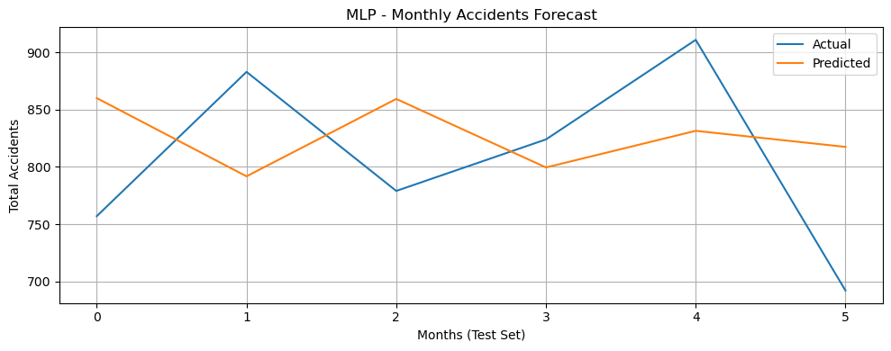

RESULT:
Thus, the program using the time series data implementation has been done successfully.

